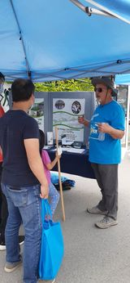
Aurora, Bruce Corbett, Chapter Chair
Spring and Fall trail inspections were conducted and reported as usual.
April 23 Over a dozen volunteers helped with the Case Woodlot Spring Clean-up.
June 5 Once again, Lissa Dwyer and her crew animated the ORTA booth at the Annual Aurora Street Festival. This is a great opportunity to inform and interest people in off-road adventures on ORTA trails.
September 14 Chapter Chair, Bruce Corbett, met on-site with Greg Scott of the Town of Aurora to plan and locate sites for 5 new posts at key trail direction changes in the Sheppard's Bush Trail. These posts were installed in October by the Town of Aurora crew. We are so glad to be able to count on the Town of Aurora trail maintenance people to accomplish major work that is beyond what ORTA volunteers can do!
Neil at Aurora Street Festival
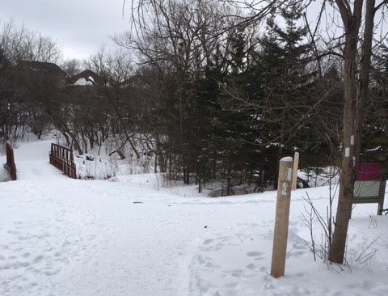
October 16 Bruce and Sharon Corbett and Trail Captain, Jody Raffensperger were among the participants on the ORTA Rendezvous Hikes at the Trail Hub. Many thanks to Brian and Wilma who led the hike which introduced us to some area trails. It was our chance to get acquainted with The Hub, a great new facility for outdoor activities.
October 23 Bruce painted the blazes on the new posts. This greatly improves trail signage for this trail which changes direction several times where other trails are present.
2022 was not a banner year in the Aurora Chapter but every year is a good one as more and more people use our trails, both the ORTA and the network of Town Trails.
New ORTA signage at Shephard’s Bush

